## 全流程：

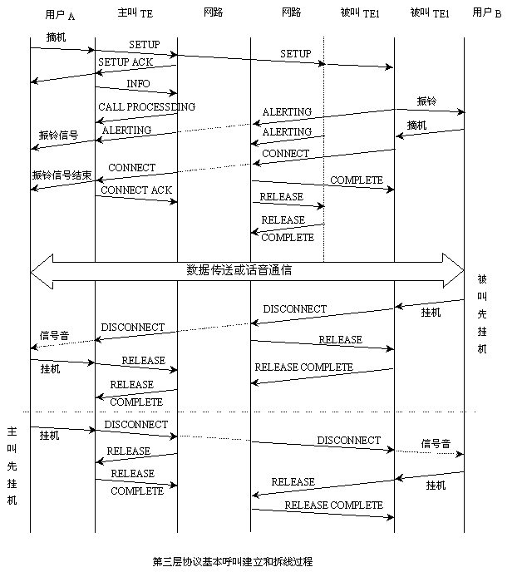

## 主叫端流程



## 1，setup

LAPD: 0 R (F) I-frame (NR=2a NS=5c)

Q.931-BRI: ref=0x001a SETUP

Bearer cap (3)

Channel Id (2)

Calling Party Number (12) 1001000000

Called Party Number (8) 8880002

< 1: ( 42) 2751332

< 00 01 b8 54 46 02 00 1a 05 04 03 80 90 a3 18 02

< ca 82 6c 0c 00 80 31 30 30 31 30 30 30 30 30 30

< 70 08 80 38 38 38 30 30 30 32

LAPD: 0 R (F) I-frame (NR=50 NS=4d)

Q.931: ref=0x0062 SETUP

Bearer cap (3)

Channel Id (4) E1=1 B-ch=30

Calling Party Number (11) 1001000000

Called Party Number (8) 8880002

WLL Facility2 (7)

> 2: ( 53) 2751332

> 00 01 9a a0 08 02 00 62 05 04 03 80 90 a3 18 04

> e9 81 83 1e 6c 0b 80 31 30 30 31 30 30 30 30 30

> 30 70 08 80 38 38 38 30 30 30 32 96 02 07 92 9e

> 07 11 96 00 01

## 2，call processding

LAPD: 0 C (F) I-frame (NR=4e NS=50)

Q.931: ref=0x8062 CALL PROC

Channel Id (4) E1=1 B-ch=30

WLL Facility2 (2)

< 2: ( 20) 2751333

< 02 01 a0 9c 08 02 80 62 02 18 04 e9 81 83 1e 96

< 02 02 93 00

LAPD: 0 C (F) I-frame (NR=5d NS=2a)

Q.931-BRI: ref=0x801a CALL PROC

Channel Id (2)

> 1: ( 13) 2751333

> 02 01 54 ba 46 02 80 1a 02 18 02 ca 82

## 3，info

LAPD: 0 C (F) I-frame (NR=4e NS=51)

Q.931: ref=0x8062 INFO

WLL Facility2 (9) Authentication data

< 2: ( 21) 2751333

< 02 01 a2 9c 08 02 80 62 7b 96 02 09 82 ff ff ff

< ff ff 00 00 00

LAPD: 0 C (F) I-frame (NR=5d NS=2b)

Q.931-BRI: ref=0x801a FACILTY

Unknown (1C) (27)

> 1: ( 38) 2751333

> 02 01 56 ba 46 02 80 1a 62 1c 1b 91 a1 18 02 01

> 01 06 07 03 a2 31 87 6c 01 09 31 0a 87 08 ac 46

> 00 00 fb 64 00 00

LAPD: 0 R (F) I-frame (NR=2c NS=5d)

Q.931-BRI: ref=0x001a FACILTY

Unknown (1C) (29)

< 1: ( 40) 2751345

< 00 01 ba 58 46 02 00 1a 62 1c 1d 91 a2 1a 02 01

< 01 30 15 06 07 03 a2 31 87 6c 01 09 31 0a 88 08

< 1b 7f 57 c1 25 83 75 b2

LAPD: 0 R (F) I-frame (NR=52 NS=4e)

Q.931: ref=0x0062 INFO

WLL Facility2 (16) Authentication result=OK

> 2: ( 28) 2751345

> 00 01 9c a4 08 02 00 62 7b 96 02 10 83 80 1b 7f

> 57 c1 25 83 75 b2 9e 07 11 96 00 01

## 4，alerting

LAPD: 0 C (F) I-frame (NR=4f NS=52)

Q.931: ref=0x8062 ALERT

Progress Indicator (2)

< 2: ( 13) 2751346

< 02 01 a4 9e 08 02 80 62 01 1e 02 82 88

LAPD: 0 C (F) I-frame (NR=5e NS=2c)

Q.931-BRI: ref=0x801a ALERT

Progress Indicator (2)

> 1: ( 13) 2751346

> 02 01 58 bc 46 02 80 1a 01 1e 02 82 88

## 5，connect

LAPD: 0 C (F) I-frame (NR=4f NS=53)

Q.931: ref=0x8062 CONN

< 2: ( 9) 2751346

< 02 01 a6 9e 08 02 80 62 07

LAPD: 0 C (F) I-frame (NR=5e NS=2d)

Q.931-BRI: ref=0x801a CONN

> 1: ( 9) 2751346

> 02 01 5a bc 46 02 80 1a 07

## 6，connect ack

LAPD: 0 R (F) I-frame (NR=2e NS=5e)

Q.931-BRI: ref=0x001a CONN ACK

< 1: ( 9) 2751348

< 00 01 bc 5c 46 02 00 1a 0f

LAPD: 0 R (F) I-frame (NR=54 NS=4f)

Q.931: ref=0x0062 CONN ACK

> 2: ( 9) 2751348

> 00 01 9e a8 08 02 00 62 0f

## 7，disc

LAPD: 0 R (F) I-frame (NR=30 NS=63)

Q.931-BRI: ref=0x001a DISC

Cause (2) cause=16

< 1: ( 13) 2751891

< 00 01 c6 60 46 02 00 1a 45 08 02 80 90

LAPD: 0 R (F) I-frame (NR=57 NS=54)

Q.931: ref=0x0062 DISC

Cause (2) cause=16

> 2: ( 13) 2751891

> 00 01 a8 ae 08 02 00 62 45 08 02 80 90

## 8，release

LAPD: 0 C (F) I-frame (NR=55 NS=57)

Q.931: ref=0x8062 REL

Cause (2) cause=16

< 2: ( 13) 2751891

< 02 01 ae aa 08 02 80 62 4d 08 02 82 90

LAPD: 0 C (F) I-frame (NR=64 NS=30)

Q.931-BRI: ref=0x801a REL

Cause (2) cause=16

> 1: ( 13) 2751891

> 02 01 60 c8 46 02 80 1a 4d 08 02 82 90

## 9，release complete

LAPD: 0 R (F) I-frame (NR=31 NS=64)

Q.931-BRI: ref=0x001a REL COM

< 1: ( 9) 2751893

< 00 01 c8 62 46 02 00 1a 5a

LAPD: 0 R (F) I-frame (NR=58 NS=55)

Q.931: ref=0x0062 REL COM

> 2: ( 9) 2751893

> 00 01 aa b0 08 02 00 62 5a